Pre Requisition for Selenium

Important Link:

<https://www.jetbrains.com/help/idea/selenium.html>

1. IntelliJ IDE: Downlaod & Install the Intellij IDE

<https://www.jetbrains.com/idea/download/?section=windows>

1. Go To setting => Plugging => Install the below pluging

Test Automation

1. Go To setting => Plugging => Install the below pluging

Selenium Pluging

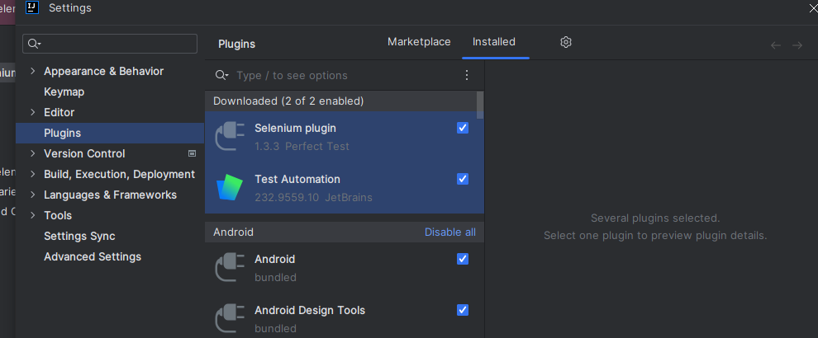

1. Downalod any browser Driver
2. Chrome: https://chromedriver.chromium.org/
3. Firebox: https://github.com/mozilla/geckodriver/releases
4. Create the Project
5. File
6. New
7. Project
8. Select The Generator = Selenium

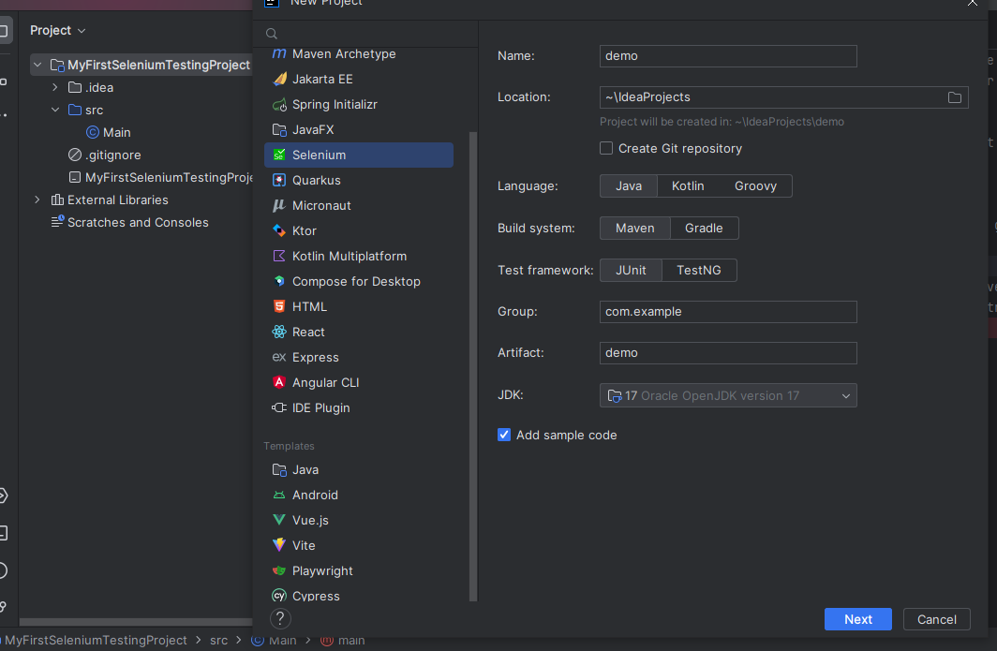

1. Write your 1st Test Cases:

package com.example.demo;  
  
import org.junit.After;  
import org.junit.Before;  
import org.openqa.selenium.WebDriver;  
import org.openqa.selenium.WebElement;  
import static org.junit.jupiter.api.Assertions.*assertTrue*;  
  
import org.openqa.selenium.By;  
import org.openqa.selenium.firefox.FirefoxDriver;  
import org.junit.Test;  
public class Page {  
 WebDriver browser;  
   
 @Before  
 public void beforeInit(){  
 //Firefox's geckodriver *requires* you to specify its location.  
 System.*setProperty*("webdriver.gecko.driver", "C:\\Users\\Abhishek\\Downloads\\geckodriver-v0.33.0-win64\\geckodriver.exe");  
   
 //browser = new ChromeDriver();  
 browser = new FirefoxDriver();  
 browser.get("https://testingbot.com");  
 }  
  
 @Test  
 public void isLogoVisible(){  
 WebElement header = browser.findElement(By.*id*("header"));  
 *assertTrue*((header.isDisplayed()));  
 }  
  
 @Test  
 public void site_header_is_on_home_page() {  
 WebElement h = browser.findElement(By.*xpath*("/html/body/div[1]/nav/div/div[1]/div/a"));  
 *assertTrue*((h.isDisplayed()));  
  
 }  
   
 @Test  
 public void isSearchBoxShowing() {  
 WebElement h = browser.findElement(By.*xpath*("/html/body/div[1]/nav/div/div[3]/a[3]"));  
 *assertTrue*((h.isDisplayed()));  
 }  
   
 @After  
 public void afetrFinish(){  
 browser.close();  
 }  
}